**DFD Diagram**

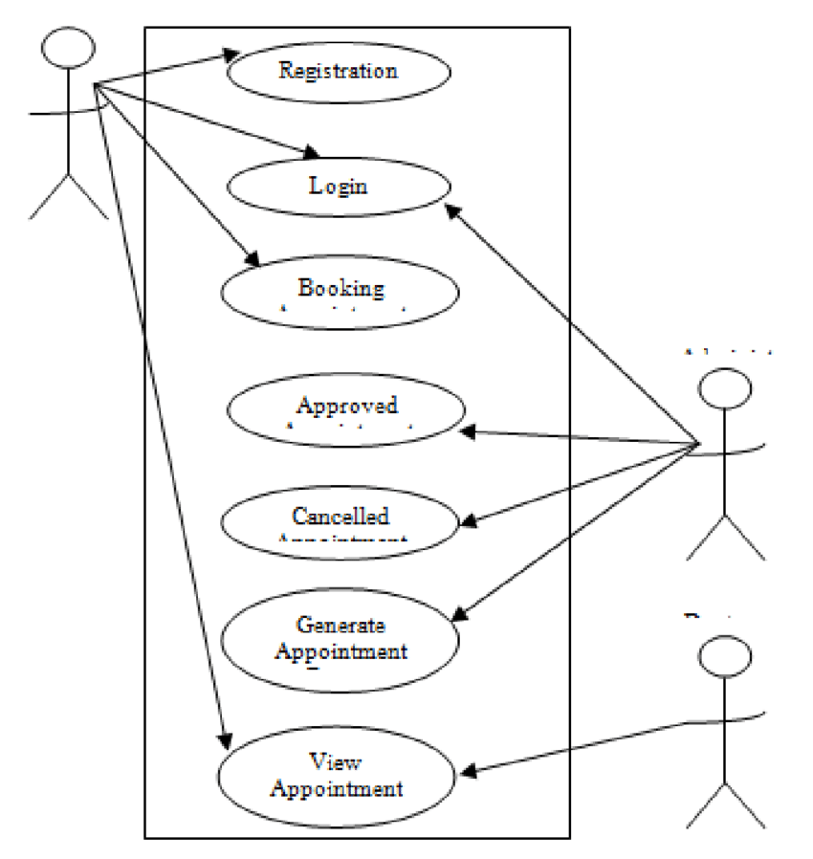

**Input And Output Screen Design**

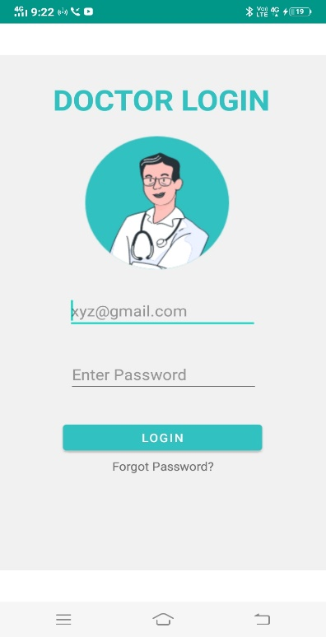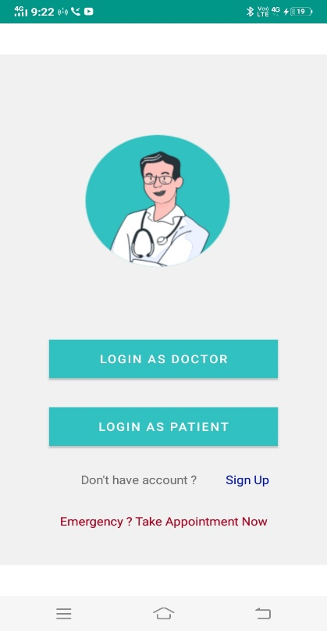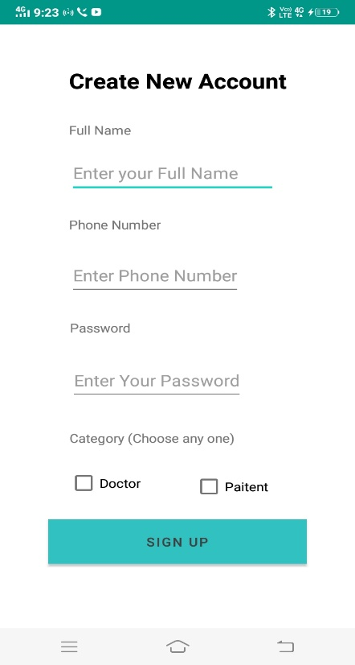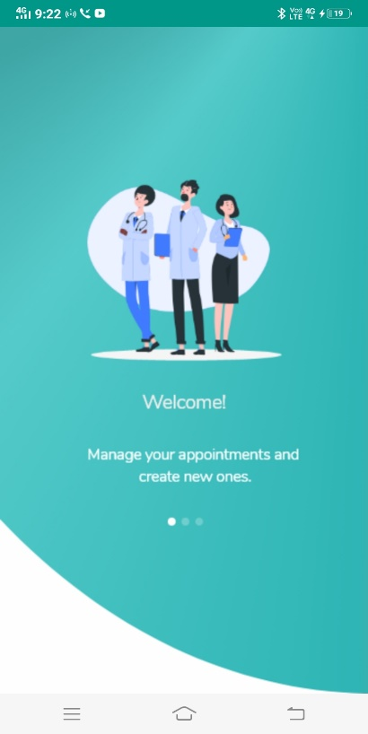

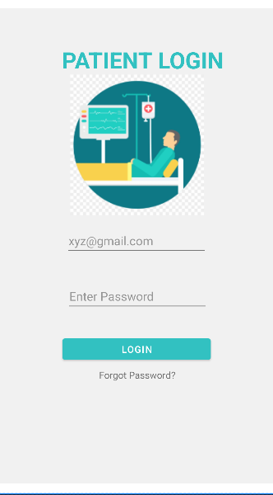

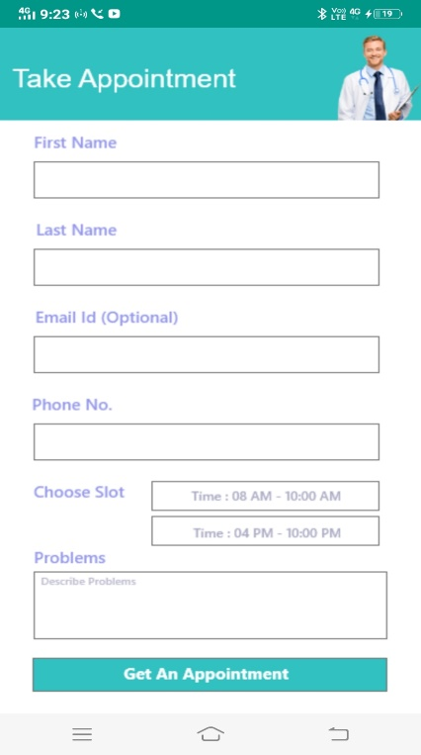

**Coding Sheets**

**Main Activity**

package com.example.lifecareclinic;  
  
import androidx.appcompat.app.AppCompatActivity;  
  
import android.content.Intent;  
import android.os.Bundle;  
  
import java.util.Timer;  
import java.util.TimerTask;  
  
public class MainActivity extends AppCompatActivity {  
  
 Timer timer;  
  
 @Override  
 protected void onCreate(Bundle savedInstanceState) {  
 super.onCreate(savedInstanceState);  
 setContentView(R.layout.activity_main);  
 timer = new Timer();  
 timer.schedule(new TimerTask() {  
 @Override  
 public void run() {  
 Intent intent= new Intent(MainActivity.this, LoginPanel.class);  
 startActivity(intent);  
 finish();  
  
 }  
 },3000);  
 }  
}

**Tab Page**

package com.example.lifecareclinic;  
  
import androidx.appcompat.app.AppCompatActivity;  
  
import android.content.Intent;  
import android.os.Bundle;  
import android.view.View;  
import android.widget.Button;  
import android.widget.ImageView;  
  
public class TabPage extends AppCompatActivity implements View.OnClickListener {  
  
 public ImageView doctor,AboutUs, appointment;  
  
  
  
 @Override  
 protected void onCreate(Bundle savedInstanceState) {  
 super.onCreate(savedInstanceState);  
 setContentView(R.layout.activity_tab_page);  
  
 doctor = (ImageView) findViewById(R.id.DoctorButton);  
 AboutUs = (ImageView) findViewById(R.id.AboutButton) ;  
 appointment = (ImageView) findViewById(R.id.AppointmentButton);  
  
 doctor.setOnClickListener(this);  
 AboutUs.setOnClickListener(this);  
 appointment.setOnClickListener(this);  
  
 }  
  
 @Override  
 public void onClick(View v) {  
 Intent intent;  
 switch (v.getId()){  
 case R.id.DoctorButton:  
 intent = new Intent(this,DoctorTab.class);  
 startActivity(intent);  
 break;  
  
 case R.id.AboutButton:  
 intent = new Intent(this,AboutUsTab.class);  
 startActivity(intent);  
 break;  
  
 case R.id.AppointmentButton:  
 intent = new Intent(this,AppointmentTab.class);  
 startActivity(intent);  
 break;  
  
 }  
  
 }  
}

**Login Panel**

package com.example.lifecareclinic;  
  
import androidx.appcompat.app.AppCompatActivity;  
  
import android.content.Intent;  
import android.os.Bundle;  
import android.view.View;  
import android.widget.Button;  
import android.widget.TextView;  
  
public class LoginPanel extends AppCompatActivity implements View.OnClickListener {  
 public Button loginAsDoctor, loginAsPaitent;  
 public TextView signUp;  
  
  
 @Override  
 protected void onCreate(Bundle savedInstanceState) {  
 super.onCreate(savedInstanceState);  
 setContentView(R.layout.activity_login_panel);  
  
 loginAsDoctor = (Button) findViewById(R.id.LoginAsDoctor);  
 loginAsPaitent = (Button) findViewById(R.id.LoginAsPaitent);  
 signUp = (TextView) findViewById(R.id.SignUp);  
  
 loginAsDoctor.setOnClickListener(this);  
 loginAsPaitent.setOnClickListener(this);  
 signUp.setOnClickListener(this);  
  
 }  
  
  
 @Override  
 public void onClick(View v) {  
 Intent i;  
 switch (v.getId()){  
 case R.id.LoginAsDoctor:  
 i = new Intent(this,DoctorLogin.class);  
 startActivity(i);  
 break;  
 case R.id.LoginAsPaitent:  
 i = new Intent(this,PaitentLogin.class);  
 startActivity(i);  
 break;  
 case R.id.SignUp:  
 i = new Intent(this,SignUp.class);  
 startActivity(i);  
 break;  
 }  
  
 }  
}

**Patient Login**

package com.example.lifecareclinic;  
  
import androidx.appcompat.app.AppCompatActivity;  
  
import android.content.Intent;  
import android.os.Bundle;  
import android.view.View;  
import android.widget.Button;  
  
public class PaitentLogin extends AppCompatActivity {  
  
 private Button button;  
  
 @Override  
 protected void onCreate(Bundle savedInstanceState) {  
 super.onCreate(savedInstanceState);  
 setContentView(R.layout.activity_paitent_login);  
  
 button = (Button) findViewById(R.id.LoginButtonPaitent);  
 button.setOnClickListener(new View.OnClickListener() {  
 @Override  
 public void onClick(View v) { openTabPage();  
  
 }  
 });  
 }  
 public void openTabPage(){  
 Intent intent = new Intent(this, TabPage.class);  
 startActivity(intent);  
 }  
}

**Welcome Screen XML Code**

<?xml version="1.0" encoding="utf-8"?>  
<androidx.constraintlayout.widget.ConstraintLayout xmlns:android="http://schemas.android.com/apk/res/android"  
 xmlns:app="http://schemas.android.com/apk/res-auto"  
 xmlns:tools="http://schemas.android.com/tools"  
 android:layout_width="match_parent"  
 android:layout_height="match_parent"  
 android:background="@drawable/welcome_screen"  
 tools:context=".MainActivity"/>

**Login Panel XML Code**

<?xml version="1.0" encoding="utf-8"?>  
<androidx.constraintlayout.widget.ConstraintLayout xmlns:android="http://schemas.android.com/apk/res/android"  
 xmlns:app="http://schemas.android.com/apk/res-auto"  
 xmlns:tools="http://schemas.android.com/tools"  
 android:id="@+id/LoginAsDoctorButton"  
 android:layout_width="match_parent"  
  
 android:layout_height="match_parent"  
 tools:context=".LoginPanel">  
  
 <ImageView  
 android:id="@+id/imageView"  
 android:layout_width="0dp"  
 android:layout_height="0dp"  
 android:src="@drawable/loginpanel"  
 app:layout_constraintBottom_toBottomOf="parent"  
 app:layout_constraintEnd_toEndOf="parent"  
 app:layout_constraintHorizontal_bias="0.0"  
 app:layout_constraintStart_toStartOf="parent"  
 app:layout_constraintTop_toTopOf="parent"  
 app:layout_constraintVertical_bias="0.0" />  
  
 <Button  
 android:id="@+id/LoginAsDoctor"  
 android:layout_width="0dp"  
 android:layout_height="0dp"  
  
 android:layout_marginStart="54dp"  
 android:layout_marginTop="381dp"  
 android:layout_marginEnd="54dp"  
 android:layout_marginBottom="35dp"  
 android:background="@color/white"  
 android:text="Login As Doctor"  
 app:layout_constraintBottom_toTopOf="@+id/LoginAsPaitent"  
 app:layout_constraintEnd_toEndOf="parent"  
 app:layout_constraintStart_toStartOf="parent"  
 app:layout_constraintTop_toTopOf="parent" />  
  
 <Button  
 android:id="@+id/LoginAsPaitent"  
 android:layout_width="0dp"  
 android:layout_height="0dp"  
 android:layout_marginStart="54dp"  
 android:layout_marginEnd="54dp"  
 android:layout_marginBottom="181dp"  
 android:background="@color/white"  
 android:text="Login As Patient"  
 app:layout_constraintBottom_toBottomOf="parent"  
 app:layout_constraintEnd_toEndOf="parent"  
 app:layout_constraintStart_toStartOf="parent"  
 app:layout_constraintTop_toBottomOf="@+id/LoginAsDoctor" />  
  
 <TextView  
 android:id="@+id/textView"  
 android:layout_width="wrap_content"  
 android:layout_height="wrap_content"  
 android:text="Don't have account ?"  
 app:layout_constraintBottom_toBottomOf="@+id/imageView"  
 app:layout_constraintEnd_toEndOf="parent"  
 app:layout_constraintHorizontal_bias="0.383"  
 app:layout_constraintStart_toStartOf="parent"  
 app:layout_constraintTop_toBottomOf="@+id/LoginAsPaitent"  
 app:layout_constraintVertical_bias="0.191" />  
  
 <TextView  
 android:id="@+id/SignUp"  
 android:layout_width="wrap_content"  
 android:layout_height="wrap_content"  
 android:text="Sign Up"  
 android:textColor="@color/purple_700"  
 app:layout_constraintBottom_toBottomOf="@+id/imageView"  
 app:layout_constraintEnd_toEndOf="parent"  
 app:layout_constraintHorizontal_bias="0.796"  
 app:layout_constraintStart_toStartOf="parent"  
 app:layout_constraintTop_toBottomOf="@+id/LoginAsPaitent"  
 app:layout_constraintVertical_bias="0.191" />  
  
 <TextView  
 android:id="@+id/Emergency"  
 android:layout_width="wrap_content"  
 android:layout_height="wrap_content"  
 android:text="Emergency ? Take Appointment Now"  
 android:textColor="@color/design_default_color_error"  
 app:layout_constraintBottom_toBottomOf="@+id/imageView"  
 app:layout_constraintEnd_toEndOf="parent"  
 app:layout_constraintStart_toStartOf="parent"  
 app:layout_constraintTop_toBottomOf="@+id/LoginAsPaitent" />  
  
  
</androidx.constraintlayout.widget.ConstraintLayout>

**Sign Up XML Code**

<?xml version="1.0" encoding="utf-8"?>  
<androidx.constraintlayout.widget.ConstraintLayout xmlns:android="http://schemas.android.com/apk/res/android"  
 xmlns:app="http://schemas.android.com/apk/res-auto"  
 xmlns:tools="http://schemas.android.com/tools"  
 android:layout_width="match_parent"  
 android:layout_height="match_parent"  
 tools:context=".SignUp">  
  
 <TextView  
 android:id="@+id/catagory"  
 android:layout_width="wrap_content"  
 android:layout_height="wrap_content"  
 android:layout_marginEnd="34dp"  
 android:layout_marginBottom="22dp"  
 android:text=" Category (Choose any one)"  
 app:layout_constraintBottom_toTopOf="@+id/paitentCheckBox"  
 app:layout_constraintEnd_toEndOf="@+id/paitentCheckBox" />  
  
 <TextView  
 android:id="@+id/createNewAccount"  
 android:layout_width="wrap_content"  
 android:layout_height="70dp"  
 android:layout_marginTop="48dp"  
 android:text="Create New Account"  
 android:textColor="@color/black"  
 android:textSize="24sp"  
 android:textStyle="bold"  
 app:layout_constraintEnd_toEndOf="parent"  
 app:layout_constraintStart_toStartOf="parent"  
 app:layout_constraintTop_toTopOf="parent" />  
  
 <TextView  
 android:id="@+id/fullName"  
 android:layout_width="wrap_content"  
 android:layout_height="wrap_content"  
 android:layout_marginTop="63dp"  
 android:text="Full Name"  
 app:layout_constraintStart_toStartOf="@+id/createNewAccount"  
 app:layout_constraintTop_toTopOf="@+id/createNewAccount" />  
  
 <EditText  
 android:id="@+id/EnterFullName"  
 android:layout_width="wrap_content"  
 android:layout_height="wrap_content"  
 android:layout_marginTop="16dp"  
 android:ems="10"  
 android:hint="Enter your Full Name"  
 android:inputType="textPersonName"  
 android:minHeight="48dp"  
 app:layout_constraintStart_toStartOf="@+id/fullName"  
 app:layout_constraintTop_toBottomOf="@+id/fullName" />  
  
 <TextView  
 android:id="@+id/phoneNumber"  
 android:layout_width="wrap_content"  
 android:layout_height="wrap_content"  
 android:layout_marginTop="25dp"  
 android:text="Phone Number"  
 app:layout_constraintStart_toStartOf="@+id/EnterFullName"  
 app:layout_constraintTop_toBottomOf="@+id/EnterFullName" />  
  
  
 <EditText  
 android:id="@+id/EnterPhoneNumber"  
 android:layout_width="wrap_content"  
 android:layout_height="wrap_content"  
 android:layout_marginTop="25dp"  
 android:hint="Enter Phone Number"  
 android:minHeight="48dp"  
 app:layout_constraintStart_toStartOf="@+id/phoneNumber"  
 app:layout_constraintTop_toBottomOf="@+id/phoneNumber" />  
  
 <TextView  
 android:id="@+id/password"  
 android:layout_width="wrap_content"  
 android:layout_height="wrap_content"  
 android:layout_marginStart="1dp"  
 android:layout_marginTop="26dp"  
 android:text="Password"  
 app:layout_constraintStart_toStartOf="@+id/EnterPhoneNumber"  
 app:layout_constraintTop_toBottomOf="@+id/EnterPhoneNumber" />  
  
 <EditText  
 android:id="@+id/enterPassword"  
 android:layout_width="wrap_content"  
 android:layout_height="wrap_content"  
 android:layout_marginTop="27dp"  
 android:hint="Enter Your Password"  
 android:minHeight="48dp"  
 app:layout_constraintStart_toStartOf="@+id/password"  
 app:layout_constraintTop_toBottomOf="@+id/password" />  
  
 <Button  
 android:id="@+id/signUpButton"  
 android:layout_width="0dp"  
 android:layout_height="51dp"  
  
 android:layout_marginStart="49dp"  
 android:layout_marginTop="86dp"  
 android:layout_marginEnd="49dp"  
 android:layout_marginBottom="94dp"  
 android:background="@color/purple_200"  
 android:text="Sign Up"  
 android:textColor="#424242"  
 app:layout_constraintBottom_toBottomOf="parent"  
 app:layout_constraintEnd_toEndOf="parent"  
 app:layout_constraintStart_toStartOf="parent"  
 app:layout_constraintTop_toTopOf="@+id/doctorCheckBox"  
 tools:ignore="TouchTargetSizeCheck" />  
  
 <CheckBox  
 android:id="@+id/doctorCheckBox"  
 android:layout_width="wrap_content"  
 android:layout_height="wrap_content"  
 android:layout_marginStart="2dp"  
 android:layout_marginTop="18dp"  
 android:text="Doctor"  
 app:layout_constraintStart_toStartOf="@+id/catagory"  
 app:layout_constraintTop_toBottomOf="@+id/catagory" />  
  
 <CheckBox  
 android:id="@+id/paitentCheckBox"  
 android:layout_width="wrap_content"  
 android:layout_height="wrap_content"  
 android:layout_marginTop="73dp"  
 android:layout_marginEnd="39dp"  
 android:text="Paitent"  
 app:layout_constraintEnd_toEndOf="@+id/signUpButton"  
 app:layout_constraintTop_toBottomOf="@+id/enterPassword" />  
  
  
</androidx.constraintlayout.widget.ConstraintLayout>

**Doctor Login XML Code**

<?xml version="1.0" encoding="utf-8"?>  
<androidx.constraintlayout.widget.ConstraintLayout xmlns:android="http://schemas.android.com/apk/res/android"  
 xmlns:app="http://schemas.android.com/apk/res-auto"  
 xmlns:tools="http://schemas.android.com/tools"  
 android:layout_width="match_parent"  
 android:layout_height="match_parent"  
 tools:context=".DoctorLogin">  
  
 <ImageView  
 android:id="@+id/imageView2"  
 android:layout_width="match_parent"  
 android:layout_height="match_parent"  
 android:src="@drawable/loginpanel"  
 app:layout_constraintBottom_toBottomOf="parent"  
 app:layout_constraintEnd_toEndOf="parent"  
 app:layout_constraintHorizontal_bias="0.66"  
 app:layout_constraintStart_toStartOf="parent"  
 app:layout_constraintTop_toTopOf="parent"  
 app:layout_constraintVertical_bias="0.0" />  
  
 <TextView  
 android:id="@+id/DoctoLogin"  
 android:layout_width="276dp"  
 android:layout_height="56dp"  
 android:layout_marginTop="68dp"  
 android:text="DOCTOR LOGIN"  
 android:textColor="@color/purple_200"  
 android:textSize="34sp"  
 android:textStyle="bold"  
 app:layout_constraintEnd_toEndOf="parent"  
 app:layout_constraintHorizontal_bias="0.697"  
 app:layout_constraintStart_toStartOf="parent"  
 app:layout_constraintTop_toTopOf="parent" />  
  
 <EditText  
 android:id="@+id/emailpalace"  
 android:layout_width="wrap_content"  
 android:layout_height="wrap_content"  
 android:ems="10"  
 android:hint="xyz@gmail.com"  
 android:inputType="textPersonName"  
 app:layout_constraintBottom_toBottomOf="parent"  
 app:layout_constraintEnd_toEndOf="parent"  
 app:layout_constraintHorizontal_bias="0.497"  
 app:layout_constraintStart_toStartOf="parent"  
 app:layout_constraintTop_toBottomOf="@+id/DoctoLogin"  
 app:layout_constraintVertical_bias="0.377" />  
  
 <EditText  
 android:id="@+id/Password"  
 android:layout_width="wrap_content"  
 android:layout_height="wrap_content"  
 android:ems="10"  
 android:hint="Enter Password"  
 android:inputType="textPassword"  
 app:layout_constraintBottom_toBottomOf="@+id/imageView2"  
 app:layout_constraintEnd_toEndOf="parent"  
 app:layout_constraintHorizontal_bias="0.502"  
 app:layout_constraintStart_toStartOf="parent"  
 app:layout_constraintTop_toTopOf="@+id/emailpalace"  
 app:layout_constraintVertical_bias="0.234" />  
  
 <Button  
 android:id="@+id/LoginButtonPaitent"  
 android:layout_width="220dp"  
 android:layout_height="43dp"  
 android:text="Login"  
 app:layout_constraintBottom_toBottomOf="parent"  
 app:layout_constraintEnd_toEndOf="parent"  
 app:layout_constraintHorizontal_bias="0.497"  
 app:layout_constraintStart_toStartOf="parent"  
 app:layout_constraintTop_toBottomOf="@+id/Password"  
 app:layout_constraintVertical_bias="0.15" />  
  
 <TextView  
 android:id="@+id/ForgotPassword"  
 android:layout_width="wrap_content"  
 android:layout_height="wrap_content"  
 android:text="Forgot Password?"  
 app:layout_constraintBottom_toBottomOf="@+id/imageView2"  
 app:layout_constraintEnd_toEndOf="parent"  
 app:layout_constraintStart_toStartOf="parent"  
 app:layout_constraintTop_toBottomOf="@+id/emailpalace" />  
  
</androidx.constraintlayout.widget.ConstraintLayout>

**Patient Login XML Code**

<?xml version="1.0" encoding="utf-8"?>  
<androidx.constraintlayout.widget.ConstraintLayout xmlns:android="http://schemas.android.com/apk/res/android"  
 xmlns:app="http://schemas.android.com/apk/res-auto"  
 xmlns:tools="http://schemas.android.com/tools"  
 android:layout_width="match_parent"  
 android:layout_height="match_parent"  
 tools:context=".PaitentLogin">  
  
 <ImageView  
 android:id="@+id/imageView2"  
 android:layout_width="match_parent"  
 android:layout_height="match_parent"  
 android:src="@drawable/paitentlogin"  
 app:layout_constraintBottom_toBottomOf="parent"  
 app:layout_constraintEnd_toEndOf="parent"  
 app:layout_constraintHorizontal_bias="0.66"  
 app:layout_constraintStart_toStartOf="parent"  
 app:layout_constraintTop_toTopOf="parent"  
 app:layout_constraintVertical_bias="0.0" />  
  
 <TextView  
 android:id="@+id/DoctoLogin"  
 android:layout_width="276dp"  
 android:layout_height="56dp"  
 android:layout_marginTop="68dp"  
 android:text="PAITENT LOGIN"  
 android:textColor="@color/purple_200"  
 android:textSize="34sp"  
 android:textStyle="bold"  
 app:layout_constraintEnd_toEndOf="parent"  
 app:layout_constraintHorizontal_bias="0.697"  
 app:layout_constraintStart_toStartOf="parent"  
 app:layout_constraintTop_toTopOf="parent" />  
  
 <EditText  
 android:id="@+id/emailpalace"  
 android:layout_width="wrap_content"  
 android:layout_height="wrap_content"  
 android:ems="10"  
 android:hint="xyz@gmail.com"  
 android:inputType="textPersonName"  
 app:layout_constraintBottom_toBottomOf="parent"  
 app:layout_constraintEnd_toEndOf="parent"  
 app:layout_constraintHorizontal_bias="0.497"  
 app:layout_constraintStart_toStartOf="parent"  
 app:layout_constraintTop_toBottomOf="@+id/DoctoLogin"  
 app:layout_constraintVertical_bias="0.377" />  
  
 <EditText  
 android:id="@+id/Password"  
 android:layout_width="wrap_content"  
 android:layout_height="wrap_content"  
 android:ems="10"  
 android:hint="Enter Password"  
 android:inputType="textPassword"  
 app:layout_constraintBottom_toBottomOf="@+id/imageView2"  
 app:layout_constraintEnd_toEndOf="parent"  
 app:layout_constraintHorizontal_bias="0.502"  
 app:layout_constraintStart_toStartOf="parent"  
 app:layout_constraintTop_toTopOf="@+id/emailpalace"  
 app:layout_constraintVertical_bias="0.234" />  
  
 <Button  
 android:id="@+id/LoginButtonPaitent"  
 android:layout_width="220dp"  
 android:layout_height="43dp"  
 android:text="Login"  
 app:layout_constraintBottom_toBottomOf="parent"  
 app:layout_constraintEnd_toEndOf="parent"  
 app:layout_constraintHorizontal_bias="0.497"  
 app:layout_constraintStart_toStartOf="parent"  
 app:layout_constraintTop_toBottomOf="@+id/Password"  
 app:layout_constraintVertical_bias="0.15" />  
  
 <TextView  
 android:id="@+id/ForgotPassword"  
 android:layout_width="wrap_content"  
 android:layout_height="wrap_content"  
 android:text="Forgot Password?"  
 app:layout_constraintBottom_toBottomOf="@+id/imageView2"  
 app:layout_constraintEnd_toEndOf="parent"  
 app:layout_constraintStart_toStartOf="parent"  
 app:layout_constraintTop_toBottomOf="@+id/emailpalace" />  
  
</androidx.constraintlayout.widget.ConstraintLayout>

**Tab Page XML code**

<?xml version="1.0" encoding="utf-8"?>  
<ScrollView xmlns:android="http://schemas.android.com/apk/res/android"  
 xmlns:app="http://schemas.android.com/apk/res-auto"  
 xmlns:tools="http://schemas.android.com/tools"  
 android:layout_width="match_parent"  
 android:layout_height="match_parent"  
 tools:context=".TabPage">  
  
 <LinearLayout  
 android:layout_width="match_parent"  
 android:layout_height="match_parent"  
 android:orientation="vertical">  
  
 <androidx.cardview.widget.CardView  
 android:layout_width="match_parent"  
 android:layout_height="wrap_content"  
 android:layout_marginTop="10sp"  
 android:layout_marginLeft="10sp"  
 android:layout_marginRight="10sp"  
  
 >  
  
 <LinearLayout  
 android:layout_width="match_parent"  
 android:layout_height="match_parent"  
  
 android:orientation="horizontal"  
 >  
 <ImageView  
 android:layout_width="match_parent"  
 android:layout_height="wrap_content"  
 android:src="@drawable/mainheader"></ImageView>  
  
 </LinearLayout>  
  
  
  
  
  
 </androidx.cardview.widget.CardView>  
  
 <androidx.cardview.widget.CardView  
 android:layout_width="match_parent"  
 android:layout_height="wrap_content"  
 android:layout_marginTop="10sp"  
 android:layout_marginLeft="10sp"  
 android:layout_marginRight="10sp"  
  
 >  
  
 <LinearLayout  
 android:layout_width="match_parent"  
 android:layout_height="wrap_content"  
  
 android:orientation="horizontal"  
 >  
  
 <ImageView  
 android:id="@+id/emergencyButton"  
 android:layout_width="match_parent"  
 android:layout_height="wrap_content"  
 android:src="@drawable/emergency">  
  
 </ImageView>  
  
  
  
 </LinearLayout>  
  
  
  
  
  
 </androidx.cardview.widget.CardView>  
  
 <GridLayout  
 android:layout_width="match_parent"  
 android:layout_height="wrap_content"  
 android:layout_marginTop="10sp"  
 android:layout_marginRight="10sp"  
 android:layout_marginLeft="10sp"  
 android:rowCount="4"  
 android:columnCount="6"  
 >  
  
 <androidx.cardview.widget.CardView  
 android:layout_gravity="fill"  
 android:layout_rowWeight="1"  
 android:layout_columnWeight="1"  
  
  
 >  
  
 <ImageView  
 android:id="@+id/DoctorButton"  
 android:layout_width="wrap_content"  
 android:layout_height="wrap_content"  
 android:layout_gravity="center"  
 android:paddingTop="30sp"  
 android:src="@drawable/doctors">  
  
 </ImageView>  
  
  
 </androidx.cardview.widget.CardView>  
  
 <androidx.cardview.widget.CardView  
 android:layout_gravity="fill"  
 android:layout_rowWeight="1"  
 android:layout_columnWeight="1"  
  
  
 >  
  
 <ImageView  
 android:id="@+id/TreatmentButton"  
 android:layout_width="wrap_content"  
 android:layout_height="wrap_content"  
 android:layout_gravity="center"  
 android:paddingTop="30sp"  
 android:src="@drawable/treatment">  
  
 </ImageView>  
  
  
 </androidx.cardview.widget.CardView>  
  
 <androidx.cardview.widget.CardView  
 android:layout_gravity="fill"  
 android:layout_rowWeight="1"  
 android:layout_columnWeight="1"  
  
  
 >  
  
 <ImageView  
 android:id="@+id/FacilityButton"  
 android:layout_width="wrap_content"  
 android:layout_height="wrap_content"  
 android:layout_gravity="center"  
 android:paddingTop="30sp"  
 android:src="@drawable/facility">  
  
 </ImageView>  
  
  
 </androidx.cardview.widget.CardView>  
  
  
  
 </GridLayout>  
  
  
  
  
 <GridLayout  
 android:layout_width="match_parent"  
 android:layout_height="wrap_content"  
 android:layout_marginTop="10sp"  
 android:layout_marginRight="10sp"  
 android:layout_marginLeft="10sp"  
 android:rowCount="4"  
 android:columnCount="6"  
 >  
  
 <androidx.cardview.widget.CardView  
 android:layout_gravity="fill"  
 android:layout_rowWeight="1"  
 android:layout_columnWeight="1"  
  
  
 >  
  
 <ImageView  
 android:id="@+id/LabButton"  
 android:layout_width="wrap_content"  
 android:layout_height="wrap_content"  
 android:layout_gravity="center"  
 android:paddingTop="30sp"  
 android:src="@drawable/labs">  
  
 </ImageView>  
  
  
 </androidx.cardview.widget.CardView>  
  
 <androidx.cardview.widget.CardView  
 android:layout_gravity="fill"  
 android:layout_rowWeight="1"  
 android:layout_columnWeight="1"  
  
  
 >  
  
 <ImageView  
 android:id="@+id/ReportButton"  
 android:layout_width="wrap_content"  
 android:layout_height="wrap_content"  
 android:layout_gravity="center"  
 android:paddingTop="30sp"  
 android:src="@drawable/reports">  
  
 </ImageView>  
  
  
 </androidx.cardview.widget.CardView>  
  
 <androidx.cardview.widget.CardView  
 android:layout_gravity="fill"  
 android:layout_rowWeight="1"  
 android:layout_columnWeight="1"  
  
  
 >  
  
 <ImageView  
 android:id="@+id/NewsButton"  
 android:layout_width="wrap_content"  
 android:layout_height="wrap_content"  
 android:layout_gravity="center"  
 android:paddingTop="30sp"  
 android:src="@drawable/news">  
  
 </ImageView>  
  
  
 </androidx.cardview.widget.CardView>  
  
  
  
 </GridLayout>  
  
  
 <GridLayout  
 android:layout_width="match_parent"  
 android:layout_height="wrap_content"  
 android:layout_marginTop="10sp"  
 android:layout_marginRight="10sp"  
 android:layout_marginLeft="10sp"  
 android:rowCount="4"  
 android:columnCount="6"  
 >  
  
 <androidx.cardview.widget.CardView  
 android:layout_gravity="fill"  
 android:layout_rowWeight="1"  
 android:layout_columnWeight="1"  
  
  
 >  
  
 <ImageView  
 android:id="@+id/GallaryButton"  
 android:layout_width="wrap_content"  
 android:layout_height="wrap_content"  
 android:layout_gravity="center"  
 android:paddingTop="30sp"  
 android:src="@drawable/gallary">  
  
 </ImageView>  
  
  
 </androidx.cardview.widget.CardView>  
  
 <androidx.cardview.widget.CardView  
 android:layout_gravity="fill"  
 android:layout_rowWeight="1"  
 android:layout_columnWeight="1"  
  
  
 >  
  
 <ImageView  
 android:id="@+id/ArticalButton"  
 android:layout_width="wrap_content"  
 android:layout_height="wrap_content"  
 android:layout_gravity="center"  
 android:paddingTop="30sp"  
 android:src="@drawable/articals">  
  
 </ImageView>  
  
  
 </androidx.cardview.widget.CardView>  
  
 <androidx.cardview.widget.CardView  
 android:layout_gravity="fill"  
 android:layout_rowWeight="1"  
 android:layout_columnWeight="1"  
  
  
 >  
  
 <ImageView  
 android:id="@+id/DocumentButton"  
 android:layout_width="wrap_content"  
 android:layout_height="wrap_content"  
 android:layout_gravity="center"  
 android:paddingTop="30sp"  
 android:src="@drawable/documents">  
  
 </ImageView>  
  
  
 </androidx.cardview.widget.CardView>  
  
  
  
 </GridLayout>  
  
 <GridLayout  
 android:layout_width="match_parent"  
 android:layout_height="wrap_content"  
 android:layout_marginTop="10sp"  
 android:layout_marginRight="10sp"  
 android:layout_marginLeft="10sp"  
 android:rowCount="4"  
 android:columnCount="6"  
 >  
  
 <androidx.cardview.widget.CardView  
 android:layout_gravity="fill"  
 android:layout_rowWeight="1"  
 android:layout_columnWeight="1"  
  
  
 >  
  
 <ImageView  
 android:id="@+id/AppointmentButton"  
 android:layout_width="wrap_content"  
 android:layout_height="wrap_content"  
 android:layout_gravity="center"  
 android:paddingTop="30sp"  
 android:src="@drawable/appointment">  
  
 </ImageView>  
  
  
 </androidx.cardview.widget.CardView>  
  
 <androidx.cardview.widget.CardView  
 android:layout_gravity="fill"  
 android:layout_rowWeight="1"  
 android:layout_columnWeight="1"  
  
  
 >  
  
 <ImageView  
 android:id="@+id/ContactButton"  
 android:layout_width="wrap_content"  
 android:layout_height="wrap_content"  
 android:layout_gravity="center"  
 android:paddingTop="30sp"  
 android:src="@drawable/contactus">  
  
 </ImageView>  
  
  
 </androidx.cardview.widget.CardView>  
  
 <androidx.cardview.widget.CardView  
 android:layout_gravity="fill"  
 android:layout_rowWeight="1"  
 android:layout_columnWeight="1"  
  
  
 >  
  
 <ImageView  
 android:id="@+id/AboutButton"  
 android:layout_width="wrap_content"  
 android:layout_height="wrap_content"  
 android:layout_gravity="center"  
 android:paddingTop="30sp"  
 android:src="@drawable/aboutus">  
  
 </ImageView>  
  
  
 </androidx.cardview.widget.CardView>  
  
  
  
 </GridLayout>  
  
  
 <GridLayout  
 android:layout_width="match_parent"  
 android:layout_height="wrap_content"  
 android:layout_marginTop="10sp"  
 android:layout_marginRight="10sp"  
 android:layout_marginLeft="10sp"  
 android:rowCount="4"  
 android:columnCount="6"  
 >  
  
 <androidx.cardview.widget.CardView  
 android:layout_gravity="fill"  
 android:layout_rowWeight="1"  
 android:layout_columnWeight="1"  
  
  
 >  
  
 <ImageView  
 android:layout_width="wrap_content"  
 android:layout_height="wrap_content"  
 android:layout_gravity="center"  
 android:paddingTop="30sp"  
 android:src="@drawable/doctors"  
 >  
  
 </ImageView>  
  
  
 </androidx.cardview.widget.CardView>  
  
 <androidx.cardview.widget.CardView  
 android:layout_gravity="fill"  
 android:layout_rowWeight="1"  
 android:layout_columnWeight="1"  
  
  
 >  
  
 <ImageView  
 android:layout_width="wrap_content"  
 android:layout_height="wrap_content"  
 android:layout_gravity="center"  
 android:paddingTop="30sp"  
 android:src="@drawable/doctors"  
 >  
  
 </ImageView>  
  
  
 </androidx.cardview.widget.CardView>  
  
 <androidx.cardview.widget.CardView  
 android:layout_gravity="fill"  
 android:layout_rowWeight="1"  
 android:layout_columnWeight="1"  
  
  
 >  
  
 <ImageView  
 android:layout_width="wrap_content"  
 android:layout_height="wrap_content"  
 android:layout_gravity="center"  
 android:paddingTop="30sp"  
 android:src="@drawable/doctors"  
 >  
  
 </ImageView>  
  
  
 </androidx.cardview.widget.CardView>  
  
  
  
 </GridLayout>  
  
  
 </LinearLayout>  
  
  
</ScrollView>

**Doctor Panel XML Code**

<?xml version="1.0" encoding="utf-8"?>  
<androidx.constraintlayout.widget.ConstraintLayout xmlns:android="http://schemas.android.com/apk/res/android"  
 xmlns:app="http://schemas.android.com/apk/res-auto"  
 xmlns:tools="http://schemas.android.com/tools"  
 android:layout_width="match_parent"  
 android:layout_height="match_parent"  
 tools:context=".DoctorTab">  
  
 <LinearLayout  
 android:layout_width="match_parent"  
 android:layout_height="match_parent"  
 android:orientation="vertical">  
  
 <androidx.cardview.widget.CardView  
 android:layout_width="match_parent"  
 android:layout_height="wrap_content"  
 android:layout_marginTop="10sp"  
 android:layout_marginLeft="10sp"  
 android:layout_marginRight="10sp"  
  
 >  
  
 <LinearLayout  
 android:layout_width="match_parent"  
 android:layout_height="match_parent"  
  
 android:orientation="horizontal"  
 >  
  
 <ImageView  
 android:id="@+id/mainheaderdoctor"  
 android:layout_width="match_parent"  
 android:layout_height="wrap_content"  
 android:src="@drawable/mainheaderdoctor"></ImageView>  
  
 </LinearLayout>  
  
  
  
  
  
 </androidx.cardview.widget.CardView>  
  
 <androidx.cardview.widget.CardView  
 android:layout_width="match_parent"  
 android:layout_height="wrap_content"  
 android:layout_marginTop="10sp"  
 android:layout_marginLeft="10sp"  
 android:layout_marginRight="10sp"  
  
 >  
  
 <LinearLayout  
 android:layout_width="match_parent"  
 android:layout_height="wrap_content"  
  
 android:orientation="horizontal"  
 >  
  
 <ImageView  
 android:id="@+id/drvishnu"  
 android:layout_width="match_parent"  
 android:layout_height="wrap_content"  
 android:src="@drawable/drvishnutab">  
  
 </ImageView>  
  
  
  
 </LinearLayout>  
  
  
  
  
  
 </androidx.cardview.widget.CardView>  
  
 <androidx.cardview.widget.CardView  
 android:layout_width="match_parent"  
 android:layout_height="wrap_content"  
 android:layout_marginTop="10sp"  
 android:layout_marginLeft="10sp"  
 android:layout_marginRight="10sp"  
  
 >  
  
 <LinearLayout  
 android:layout_width="match_parent"  
 android:layout_height="wrap_content"  
  
 android:orientation="horizontal"  
 >  
  
 <ImageView  
 android:id="@+id/drajayinfo"  
 android:layout_width="match_parent"  
 android:layout_height="wrap_content"  
 android:src="@drawable/drajay">  
  
 </ImageView>  
  
  
  
 </LinearLayout>  
  
  
  
  
  
 </androidx.cardview.widget.CardView>  
  
 <androidx.cardview.widget.CardView  
 android:layout_width="match_parent"  
 android:layout_height="wrap_content"  
 android:layout_marginTop="10sp"  
 android:layout_marginLeft="10sp"  
 android:layout_marginRight="10sp"  
  
 >  
  
 <LinearLayout  
 android:layout_width="match_parent"  
 android:layout_height="wrap_content"  
  
 android:orientation="horizontal"  
 >  
  
 <ImageView  
 android:id="@+id/dramit"  
 android:layout_width="match_parent"  
 android:layout_height="wrap_content"  
 android:src="@drawable/amitlakhiwal">  
  
 </ImageView>  
  
  
  
 </LinearLayout>  
  
  
  
  
  
 </androidx.cardview.widget.CardView>  
 </LinearLayout>  
  
</androidx.constraintlayout.widget.ConstraintLayout>

**About Us XML Code**

<?xml version="1.0" encoding="utf-8"?>  
<androidx.constraintlayout.widget.ConstraintLayout xmlns:android="http://schemas.android.com/apk/res/android"  
 xmlns:app="http://schemas.android.com/apk/res-auto"  
 xmlns:tools="http://schemas.android.com/tools"  
 android:layout_width="match_parent"  
 android:layout_height="match_parent"  
 android:background="@drawable/aboutustab"  
 tools:context=".AboutUsTab">  
  
</androidx.constraintlayout.widget.ConstraintLayout>

**Testing**

